EDGE INTELLIGENCE LAB 5 – 10th January 2026

SWETHA K
25MML0008

TASK : Implementing a model on the dataset obtained from clicking pictures by connecting mobile phone to Edge Impulse.

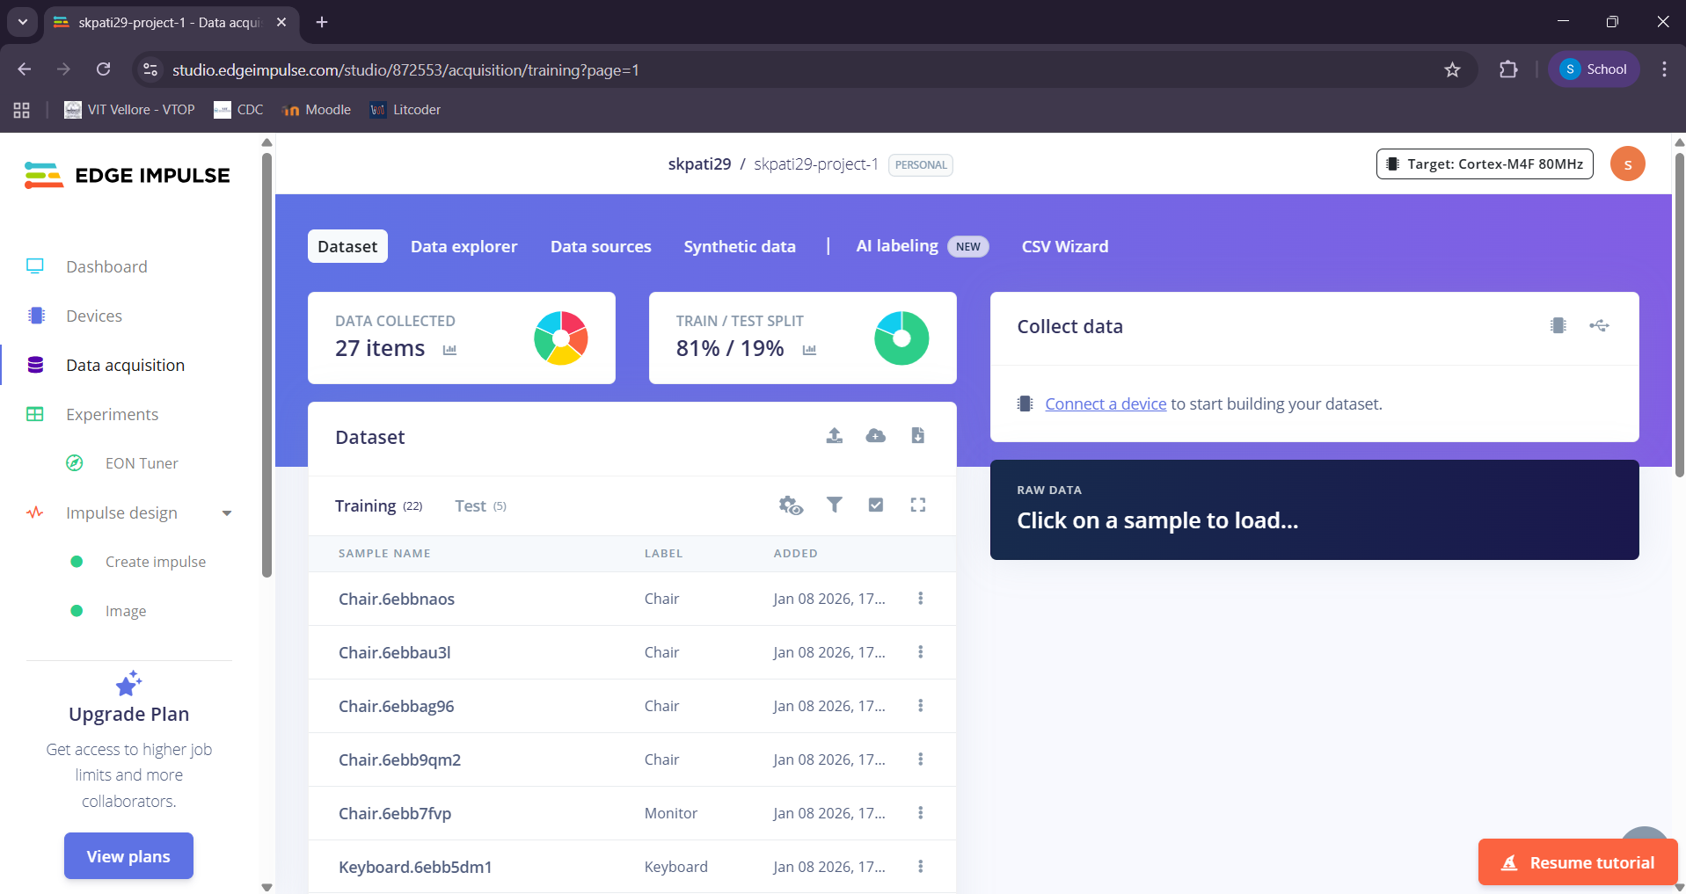

Creating Impulse : We connect our images by adding a process block then adding a learning block – Classifier by connecting our images to this block. Then, we save this impulse.
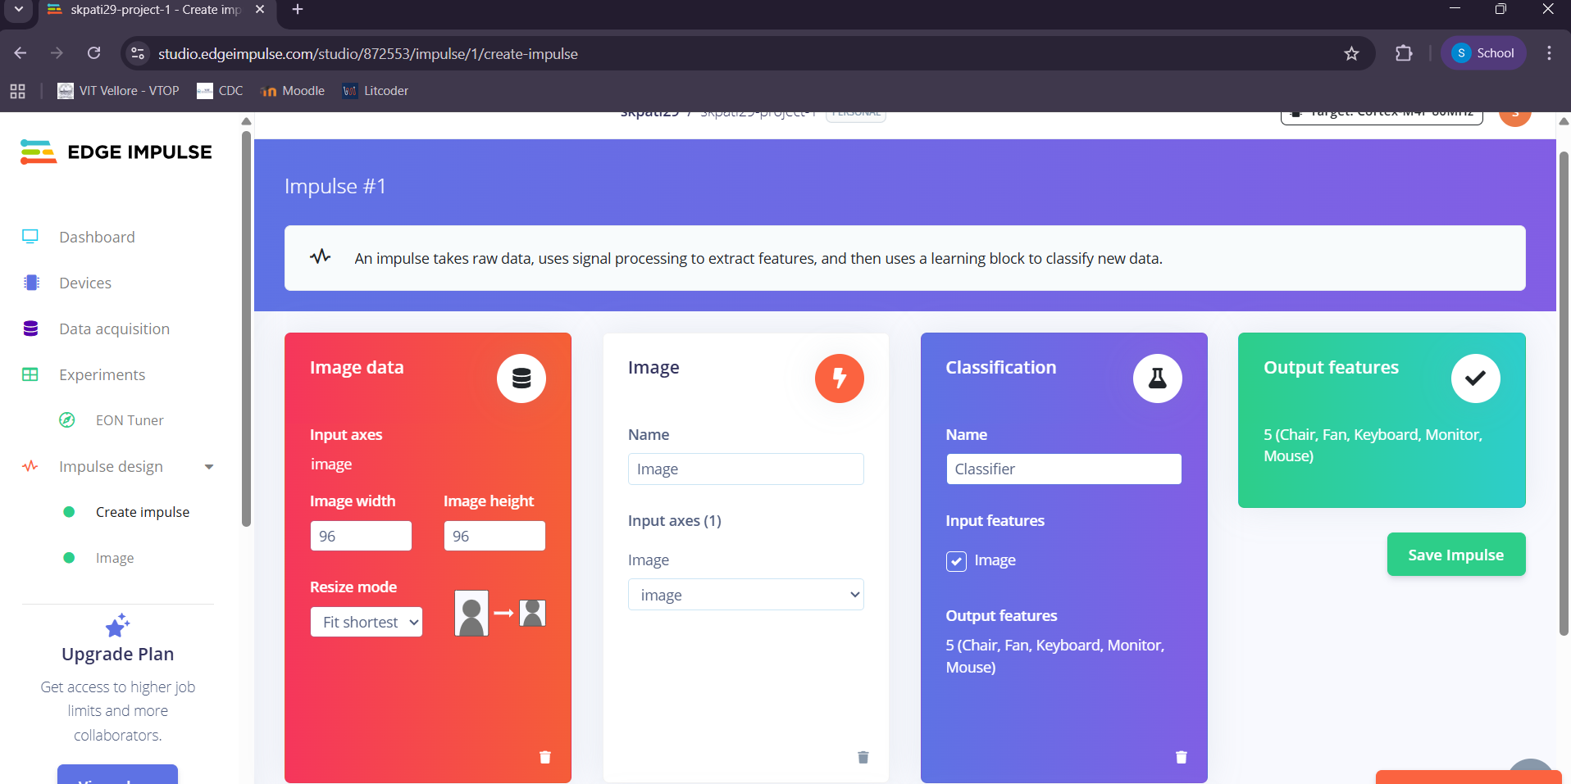
Next we go to the image section, we set the color depth to GreyScale and save our parameters.
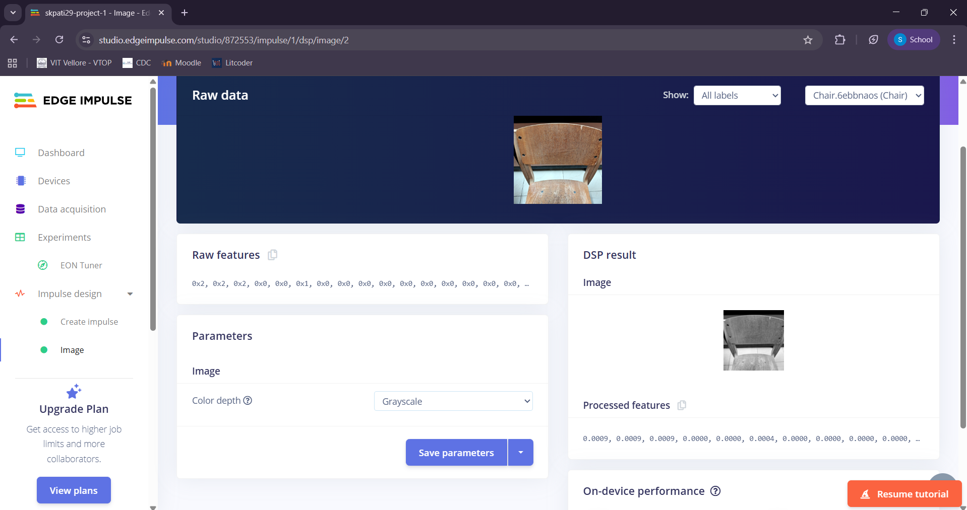

Next, we generate our features for the 5 classes (Chair, Mouse,Keyboard,Fan,Monitor)

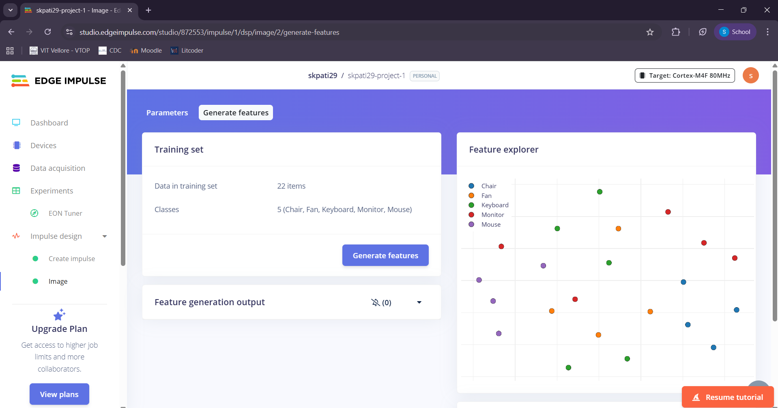

Next, we go to the Classification section – we see that our Neural Network architecture has 5 layers – Input layer, Con2D/Max pool, Con2D/Max pool, Flatten, Dropout, and output.
Input layer has 9216 features , because our image is greyscale (96*96 image) and the output has 5 classes.
We set the number of Epochs to 30, learning rate to 0.01 and achieved a 60% accuracy with a loss of 1.3.
